Analysis & Design

graded unit 2

James Park | Software Development | 19/04/2023

Contents

Introduction 3

Use Case Diagrams 4

Use case diagram – creating a booking 4

use case diagram – registering a new employee 5

Detailed Class Diagram 7

Activity Diagrams 8

Activity Diagram – creating a booking 8

9

Activity diagram – register a new employee 9

Sequence Diagrams 10

Sequence Diagram – creating a booking 10

Sequence diagram – register a new employee 11

Normalization 12

booking form 12

normolized 13

ER Diagram 15

Screen Layouts 16

unregistered user views 17

Unregistered Home 18

Login 19

Register 20

customer user views 21

Registered Home 22

My Profile 23

Edit Profile 24

Add Dog 25

Edit Dog 26

Create Booking 27

Confirm Booking 28

View Booking 29

employee user views 30

Dashboard 31

View All Bookings 32

View All Employees 33

Create Employees 34

Edit Employees 35

Employee Profile 36

# Introduction

This document is to present all the UML diagrams I created during the analysis of my project requirements. It also showcases my initial ideas for the design and layout of each of the main pages of my website for unregistered users, registered customer users, and employee users.

# Use Case Diagrams

## Diagram Description automatically generatedUse case diagram – creating a booking

## use case diagram – registering a new employee

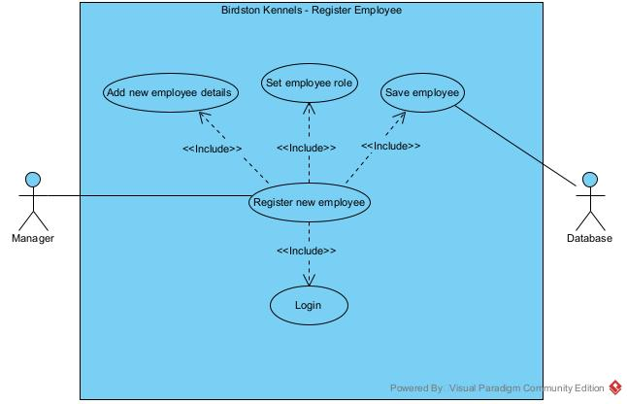

# Detailed Class Diagram

# Activity Diagrams

## Activity Diagram – creating a booking

## 

## Activity diagram – register a new employee

# Sequence Diagrams

## Sequence Diagram – creating a booking

## Sequence diagram – register a new employee

# Normalization

## A picture containing timeline Description automatically generatedbooking form

## normolized

|  |  |  |  |  |  |  |
| --- | --- | --- | --- | --- | --- | --- |
| Un-normalized | First Form | Second Form | Third Form | | Names | |
| Booking ID  (Owner Name)  Date  Arrival Date & Time  Departure Date & Time  ~~Number of Nights~~  Owners Name  (Address Line 1)  (Address Line 2)  (Town)  (Postcode)  (Phone Number)  (Dogs name)  (Dog Breed  (Dog Gender)  (Dog Age)  (Neutered/Spayed?)  (Vet Name)  (Vet Address Line 1)  (Vet Address Line 2)  (Vet Town)  (Vet Postcode)  (Vet Phone number)  (Proof of Vaccination?)  (Proof of Flea/Worming)  (Operations in last 6 week)  (Allergies)  (Current Medications)  (Microchip Details)  (Home Email)  (Collar & Tag Supplied?)  (Permission to let off leash)  (Antisocial Behaviors?)  (Emergency Contacts Name)  (Emergency Contact Number) | Booking ID  Date  Arrival Date & Time  Departure Date & Time  Booking ID  Owner Name  Dogs name  Address Line 1  Address Line 2  Town  Postcode  Phone Number  Dog Breed  Dog Gender  Dog Age  Neutered/Spayed?  Vet Name  Vet Address Line 1  Vet Address Line 2  Vet Town  Vet Postcode  Vet Phone number  Proof of Vaccination?  Proof of Flea/Worming  Operations in last 6 week  Allergies  Current Medications  Microchip Details  Home Email  Collar & Tag Supplied?  Permission to let off leash.  Antisocial Behaviors?  Emergency Contacts Name  Emergency Contact Number | Booking ID  Date  Arrival Date & Time  Departure Date & Time  Dogs Name  Dog Breed  Dog Gender  Dog Age  Neutered/Spayed?  Vet Name  Vet Address Line 1  Vet Address Line 2  Vet Town  Vet Postcode  Vet Phone number  Proof of Vaccination?  Proof of Flea/Worming  Operations in last 6 week  Allergies  Current Medications  Microchip Details  Collar & Tag Supplied?  Permission to let off leash.  Antisocial Behaviors?  Booking ID  Customer ID  Customer ID  Owner Name  Address Line 1  Address Line 2  Town  Postcode  Phone Number  Emergency Contacts Name  Emergency Contact Number  Home Email | | Booking ID  Date  Arrival Date & Time  Departure Date & Time  *\* Dog ID*  Customer ID  Booking ID  Customer ID  Owner Name  Address Line 1  Address Line 2  Town  Postcode  Phone Number  Emergency Contacts Name  Emergency Contact Number  Home Email  Dog ID  * Vet ID  Dogs Name  Dog Breed  Dog Gender  Dog Age  Neutered/Spayed?  Proof of Vaccination?  Proof of Flea/Worming  Operations in last 6 week  Allergies  Current Medications  Microchip Details  Collar & Tag Supplied?  Permission to let off leash.  Antisocial Behaviors?  Vet ID  Vet Name  Vet Address Line 1  Vet Address Line 2  Vet Town  Vet Postcode  Vet Phone number | | Bookings  Customers Bookings  Customers  Dogs  Vets |

# ER Diagram

# Screen Layouts

## unregistered user views

### Unregistered Home

### Login

### Register

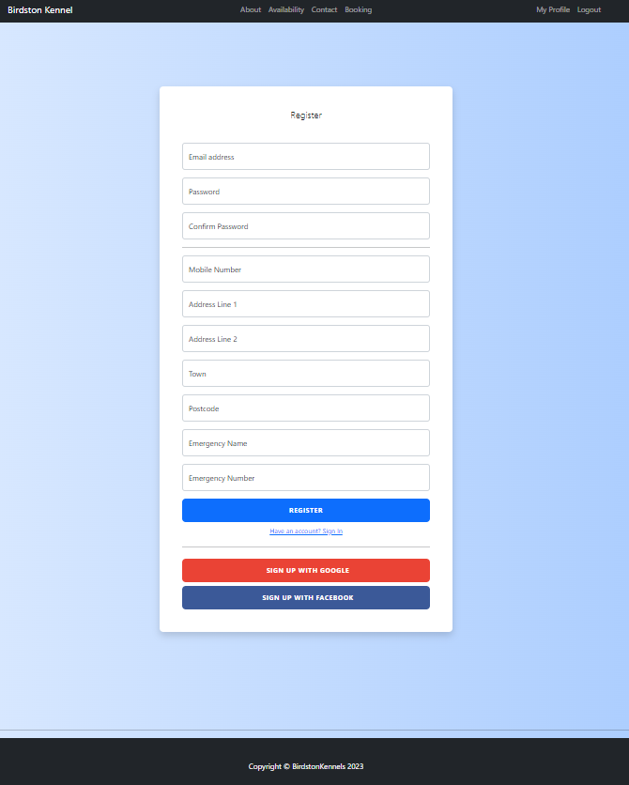

## customer user views

### Registered Home

### My Profile

### Edit Profile

### Add Dog

### Edit Dog

### Create Booking

### Confirm Booking

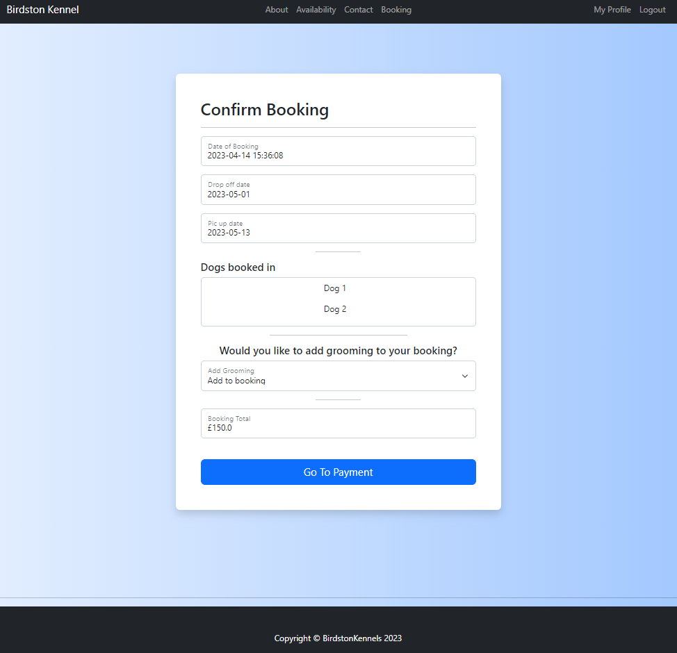

### View Booking

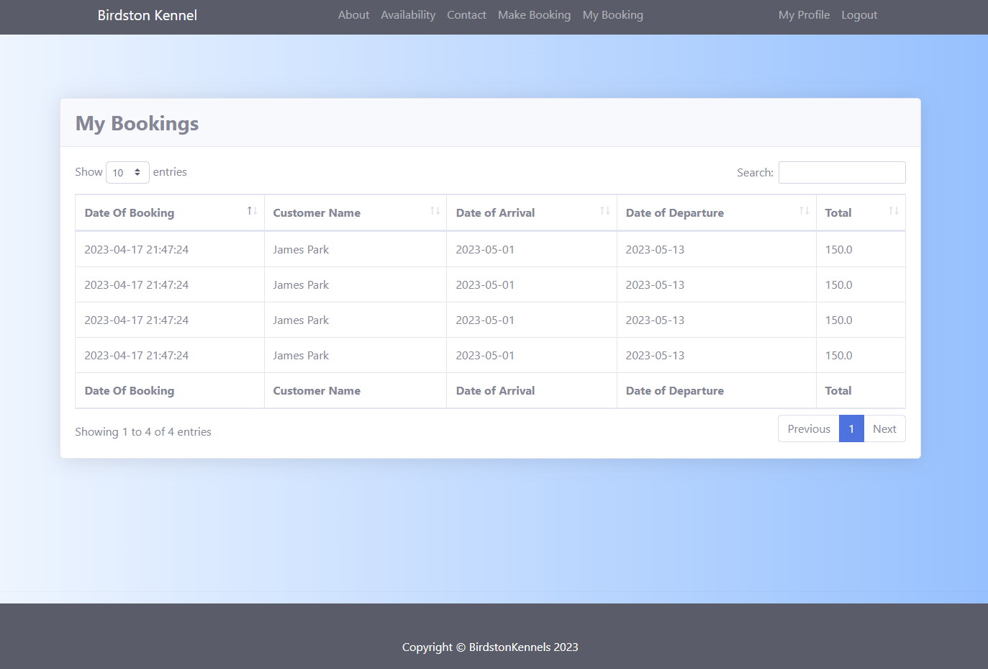

## employee user views

### Dashboard

### View All Bookings

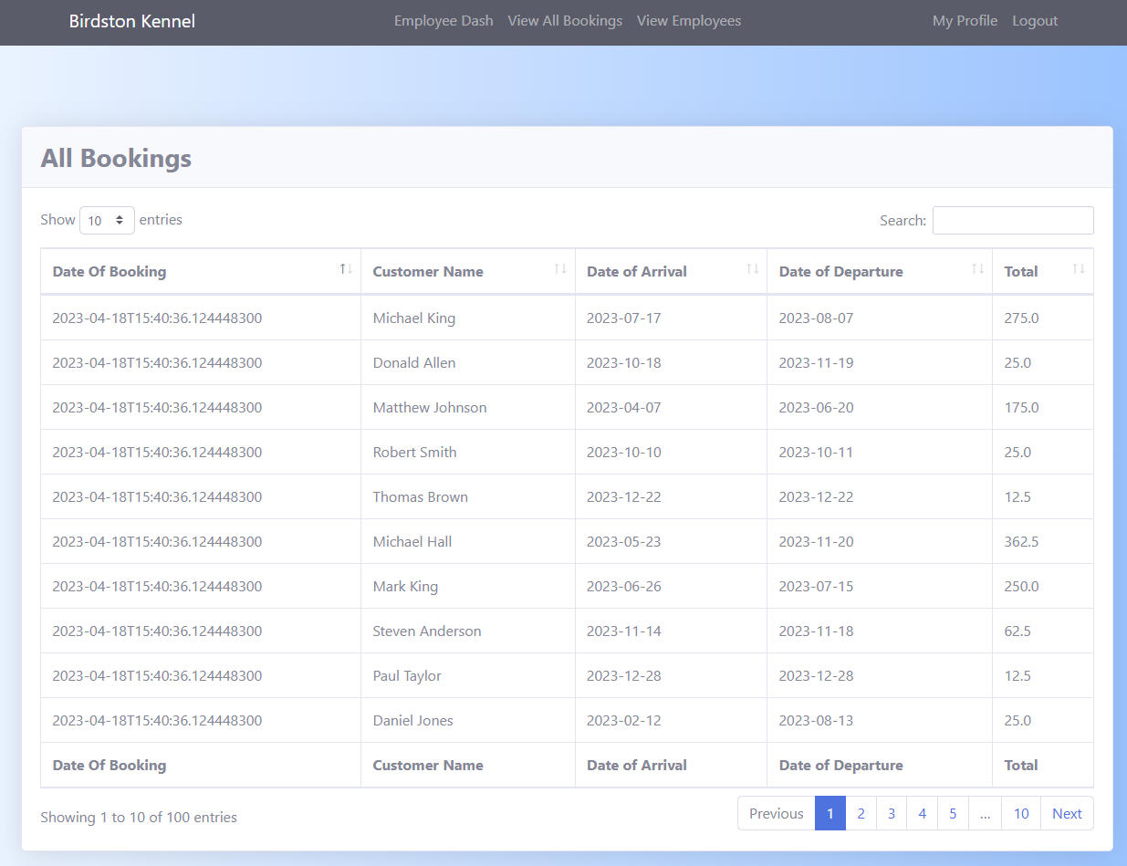

### View All Employees

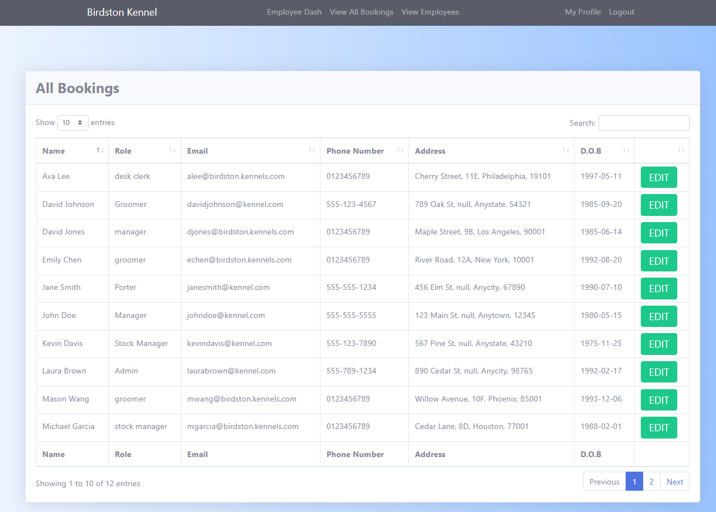

### Create Employees

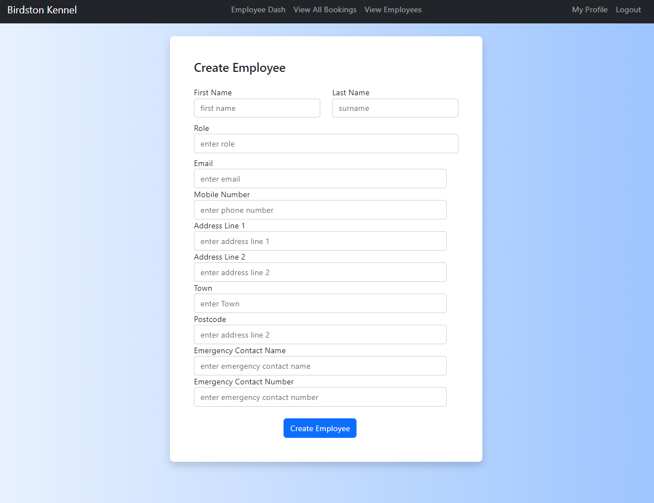

### Edit Employees

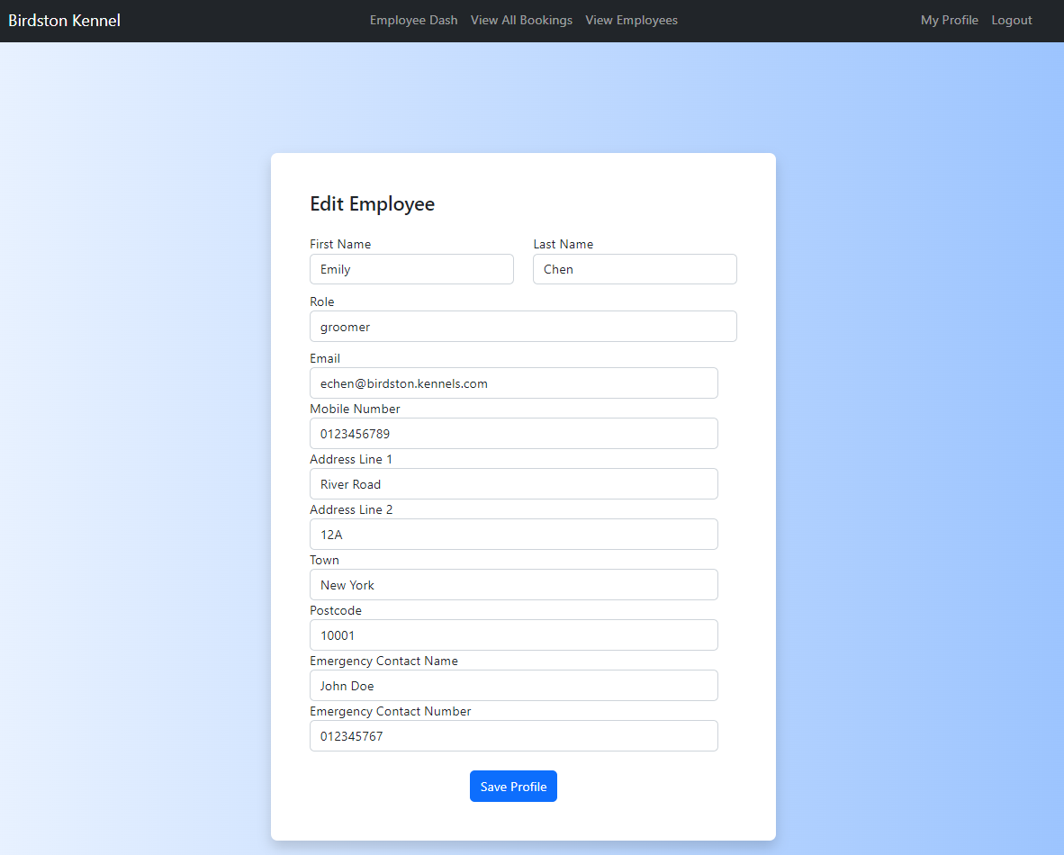

### Employee Profile

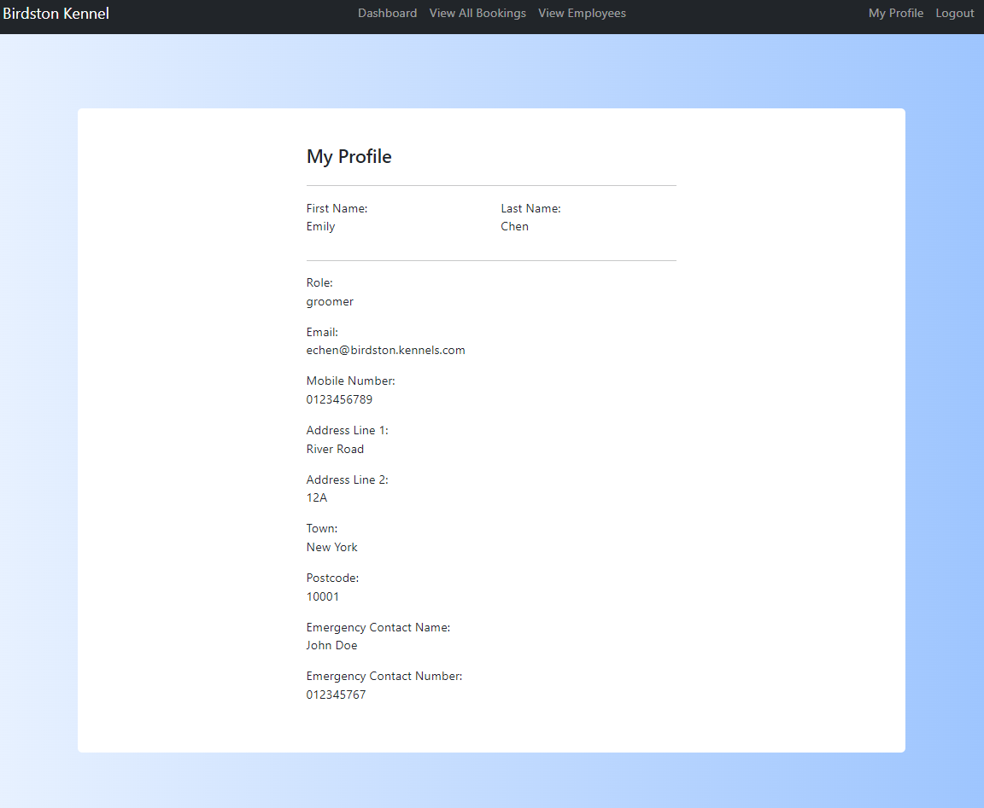

# Event Handlers

|  |  |  |  |  |
| --- | --- | --- | --- | --- |
| **Birdston Kennels** |  |  | | |
| **Event Handling** |  |  | | |
| **Form:** booking/create_booking.html | | |  |  |
| Name | Event | Description | | |
| Drop-off Date  Pick-up Date  Add Dog  Confirm Booking | onChange  onChange  onClick  onClick | Check that the entered date is before the current date  Check that the entered date is not before the drop-off date  Navigates the user the add_dog view  Sends the entered booking data to the createBooking method in the booking controller which will validate the booking and send the user to the confirm booking view if successful | | |
| **Date:** 21/04/2023 | **System:** Birdston Kennels | **Name:** James R Park | | |

|  |  |  |  |  |
| --- | --- | --- | --- | --- |
| **Birdston Kennels** |  |  | | |
| **Event Handling** |  |  | | |
| **Form:** staff/create_employee.html | | |  |  |
| Name | Event | Description | | |
| Create Employee | onClick | sends the entered details for the new employee to the database to be validated if successful the user will be asked to confirm the details in the confirm_new_employee view if not they will be shown an error | | |
| **Date:** 21/04/2023 | **System:** Birdston Kennels | **Name:** James R Park | | |

# Module Description

|  |  |  |  |
| --- | --- | --- | --- |
| **Birdston Kennels** |  | |  |
| **Controller:** Booking |  | |  |
| **Module Description** |  | |  |
| **Module Title: createBooking** | | | |
| **Description:**  This module is used for taken the entered. This method is a post method from when the create booking form is submitted by the user | | | |
| **Pseudo Code:**  Get arrivalDate from Model  Get departureDate from Model  If arivalDate is before now  Throw error  Else if departure date is before arrivalDate  Throw error  Get Dogs  Check dogs have are valid for stay  If not valid  Throw error  Create new Booking object  Set arrivalDate  Set departureDate  Set dateOfBooking to now  Set customer to current user  Set dogs  If available kennel is not found  Throw error  Calculate price  Set price  Set Kennel  Return booking to confirmBooking view  If user agrees to booking booking is returned  If grooming requested  Set grooming true  Else  Set grooming false  Redirect to payment process  If booking successful  Store booking in database  Send confirmation email  Else  Throw error  Cancel order | | | |
| **Date:** 21/04/2023 | | **System:** Birdston Kennels | **Name:** James R Park |

|  |  |  |  |
| --- | --- | --- | --- |
| **Birdston Kennels** |  | |  |
| **Controller:** Booking |  | |  |
| **Module Description** |  | |  |
| **Module Title:** CreateEmployee | | | |
| **Description:**  This module is used for a manager to create a new employee in the database. It is a post method for the create employee view and returns a redirect to view employees page | | | |
| **Pseudo Code:**  Get details from model for new user  Get first name  Get last name  Create email by Concatenating “firstname + ‘.’ + lastname + ‘@birdstonkennels.com’”    Set email  Set details based on model  Try  Add user to database  If fail  Throw error  Redirect user to the view employees page | | | |
| **Date:** 21/04/2023 | | **System:** Birdston Kennels | **Name:** James R Park |